Chapter 12, Solution 62.

Using Fig. 12.68, design a problem to help other students to better understand how to use PSpice to analyze three-phase circuits.

Although there are many ways to solve this problem, this is an example based on the same kind of problem asked in the third edition.

Problem

The circuit in Fig. 12.68 operates at 60 Hz. Use PSpice to find the source current I_{ab} and the line current I_{bB}.

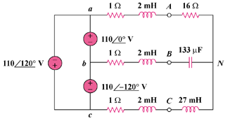

Figure 12.68

Solution

Because of the delta-connected source involved, we follow Example 12.12. In the AC Sweep box, we type Total Pts = 1, Start Freq = 60, and End Freq = 60. After simulation, the output file includes

FREQ IM(V_PRINT2) IP(V_PRINT2)

6.000 E+01 5.960 E+00 –9.141 E+01

FREQ IM(V_PRINT1) IP(V_PRINT1)

6.000 E+01 7.333 E+07 1.200 E+02

From which
I_{ab} = 3.432∠-46.31° A, I_{bB} = 10.39∠–78.4° A

